# AWS EC2 Instance Deployment Guide

## Step 1: Login to AWS Console

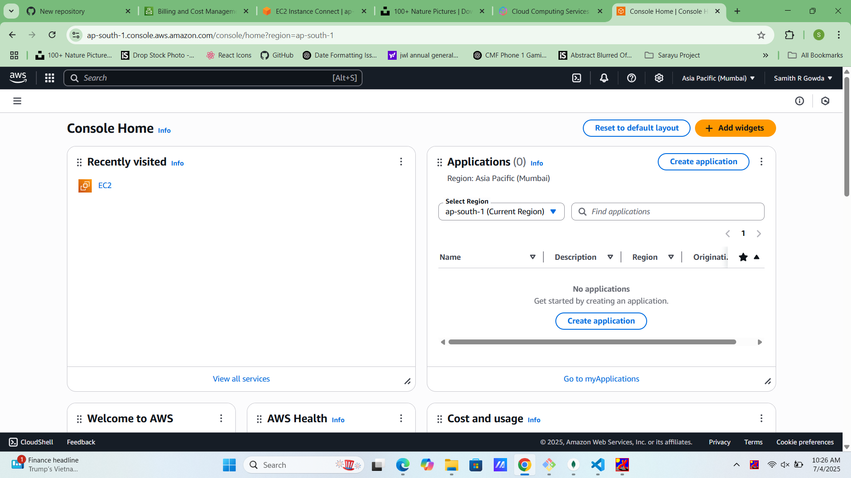

Login to your AWS account and navigate to EC2 Dashboard.

## Step 2: Launch Instance

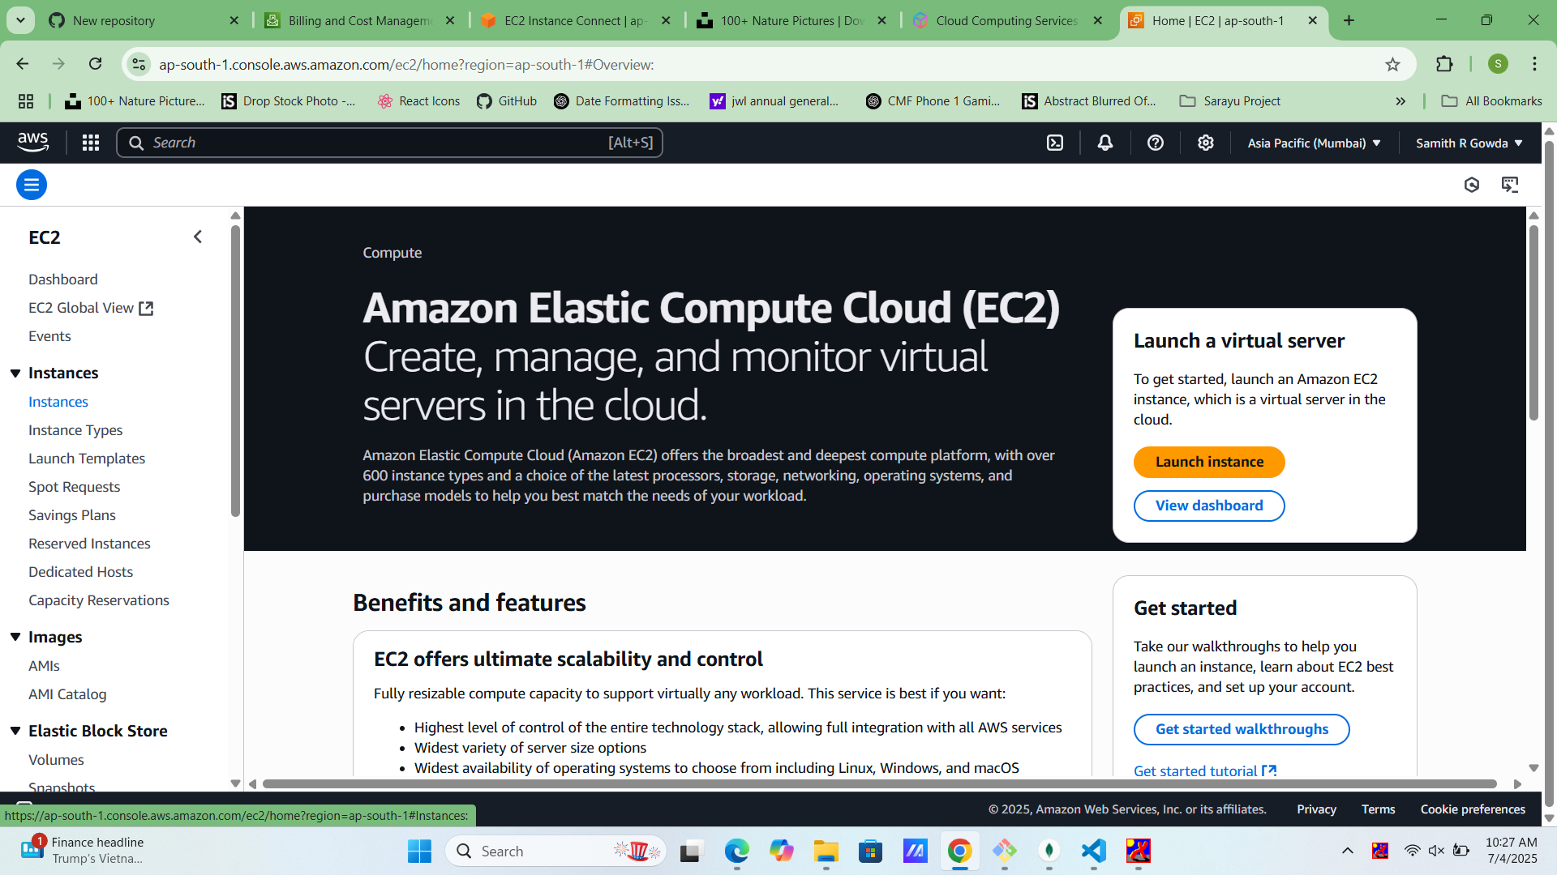

Click on 'Launch Instance' to start the configuration.

## Step 3: Name and Image

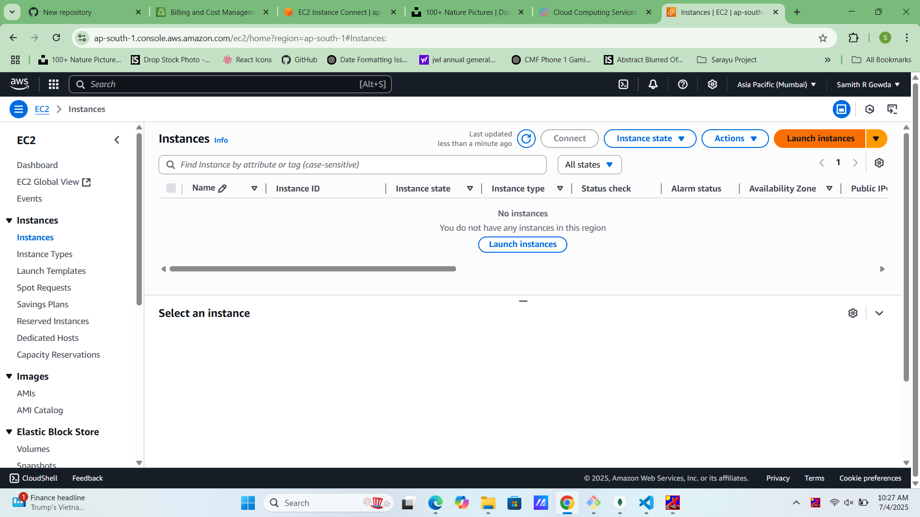

Provide a name for your instance and select an Amazon Machine Image (AMI).

## Step 4: Choose Instance Type

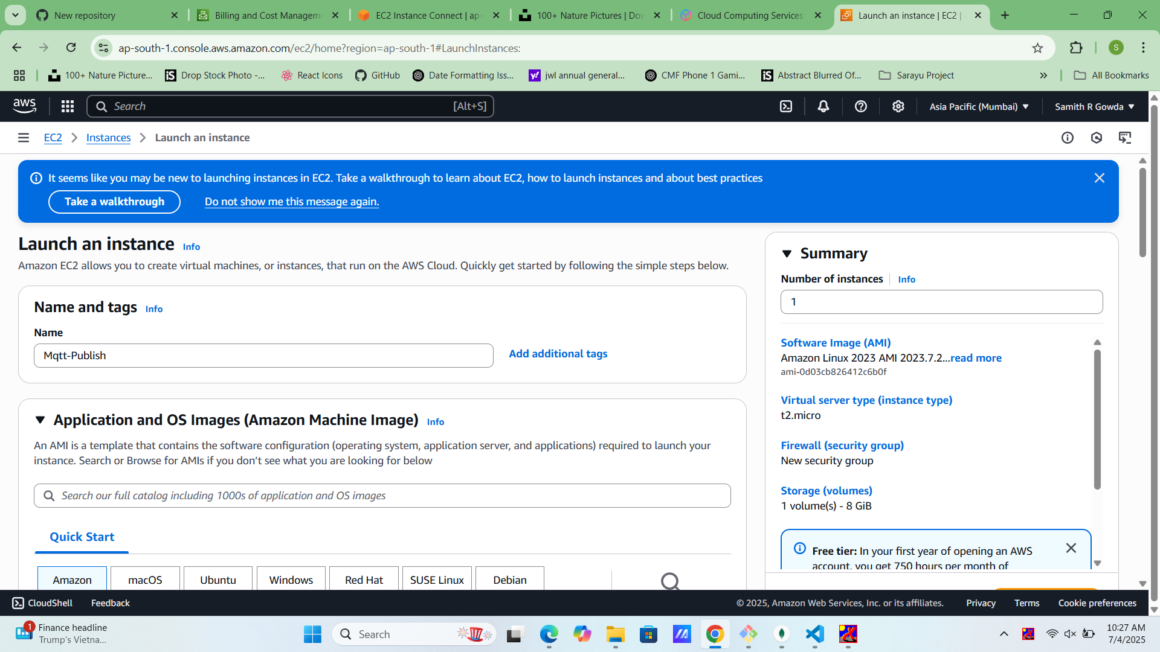

Select an instance type (e.g., t2.micro) for free tier usage.

## Step 5: Configure Key Pair

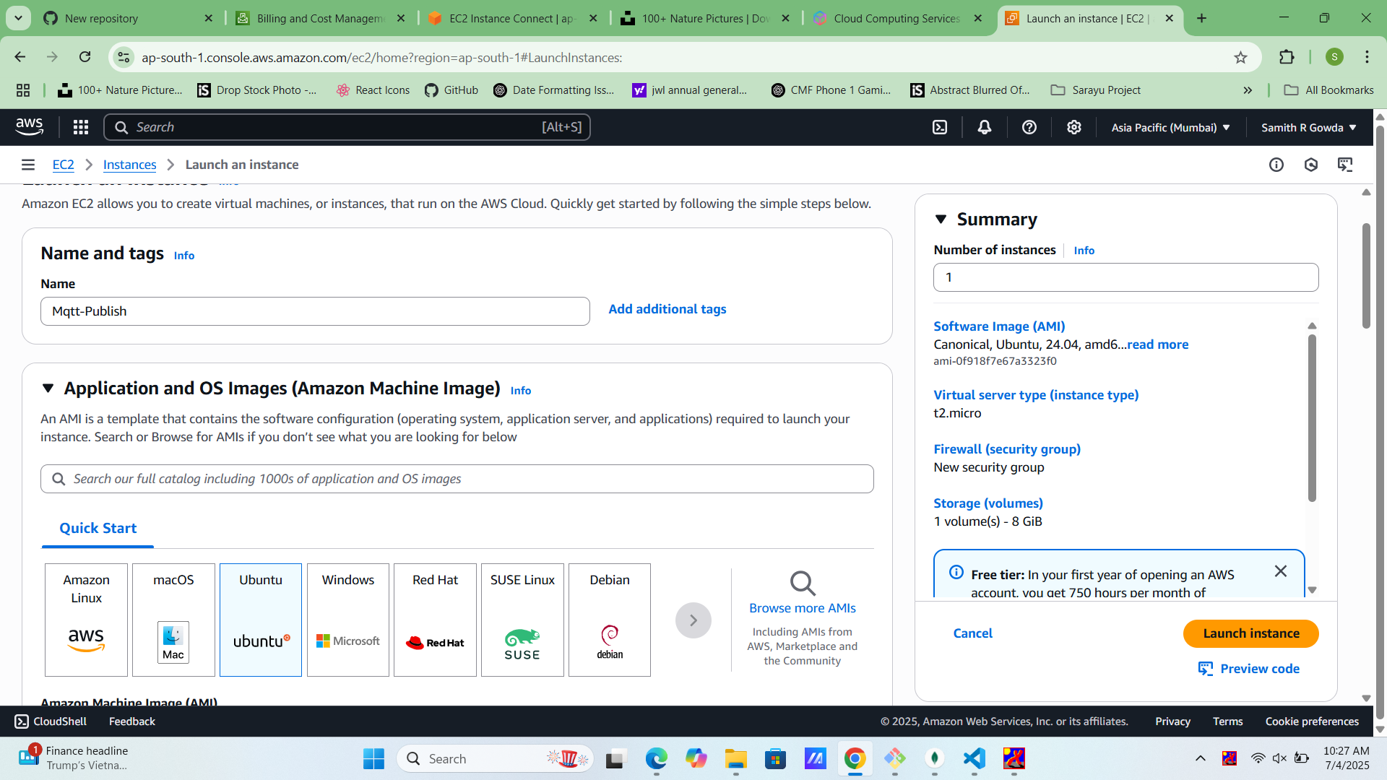

Create or choose an existing key pair to access the instance securely.

## Step 6: Network Settings

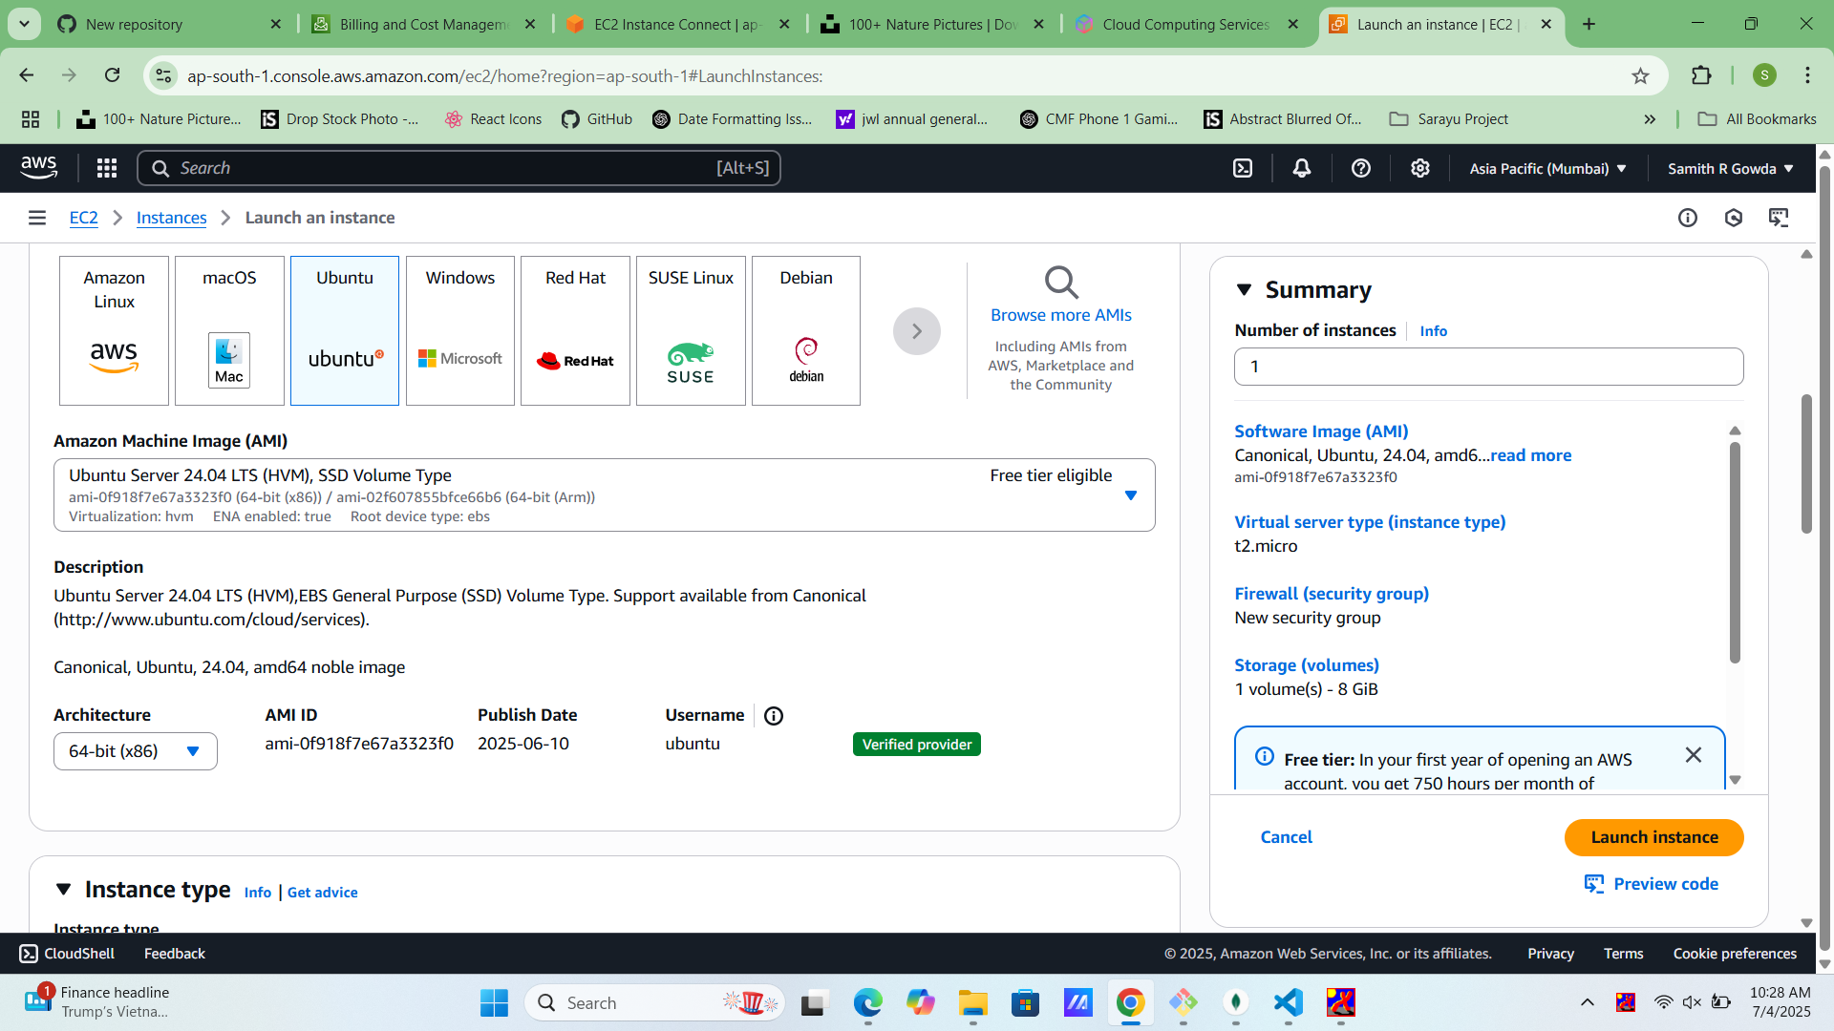

Set VPC and subnet, enable Auto-assign public IP, and configure firewall rules.

## Step 7: Add Storage

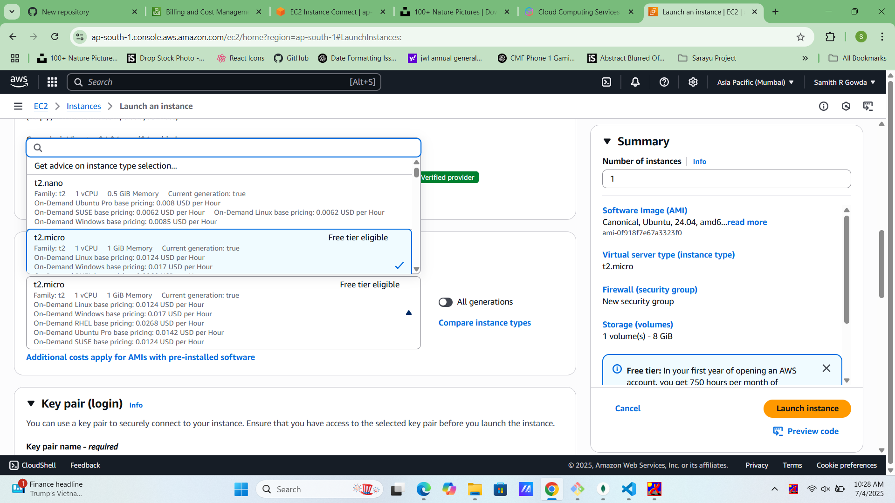

Specify storage volume size and type as required.

## Step 8: Add Tags

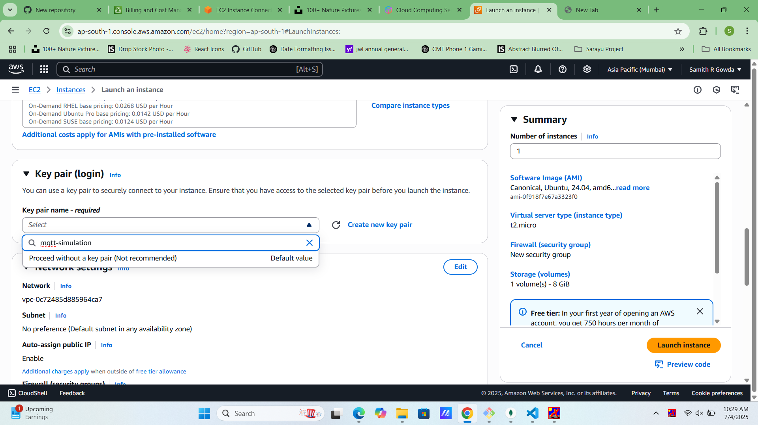

Add tags to organize and identify your instance.

## Step 9: Configure Security Group

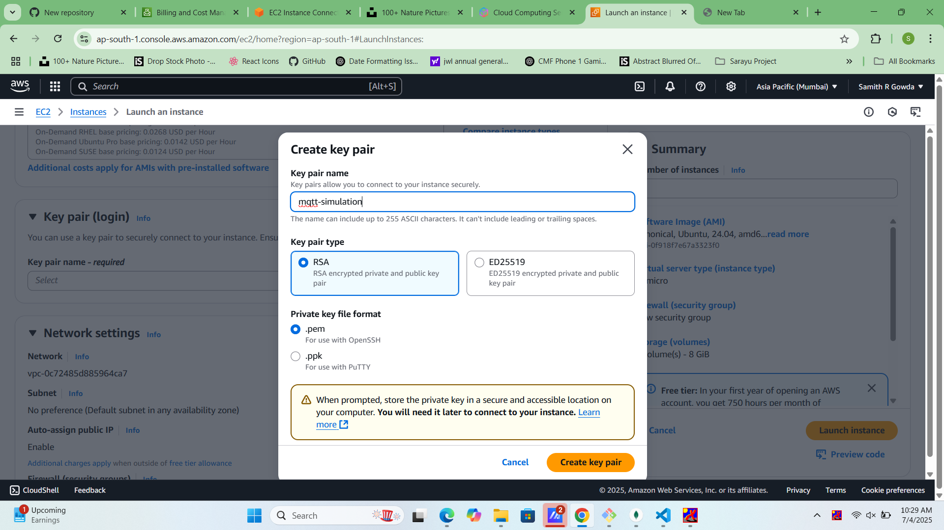

Set inbound rules (e.g., allow SSH (22), HTTP (80), HTTPS (443)).

## Step 10: Review and Launch

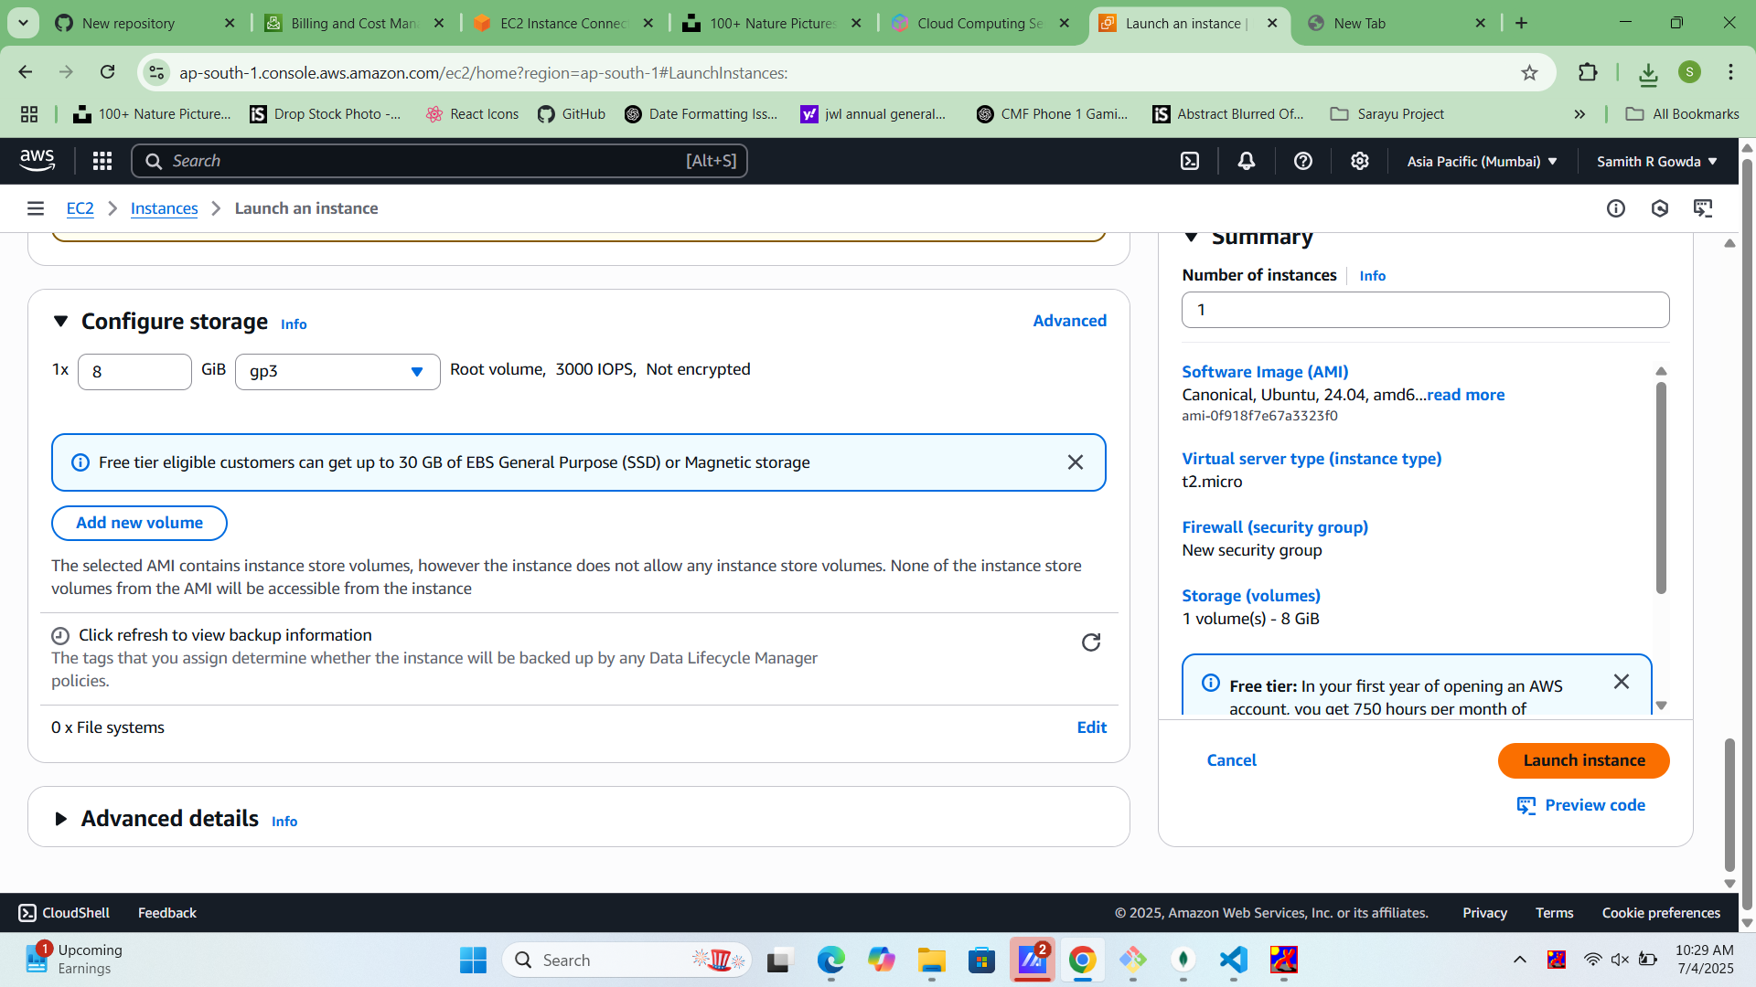

Review instance settings and click on 'Launch Instance'.

## Step 11: Instance Launch Confirmation

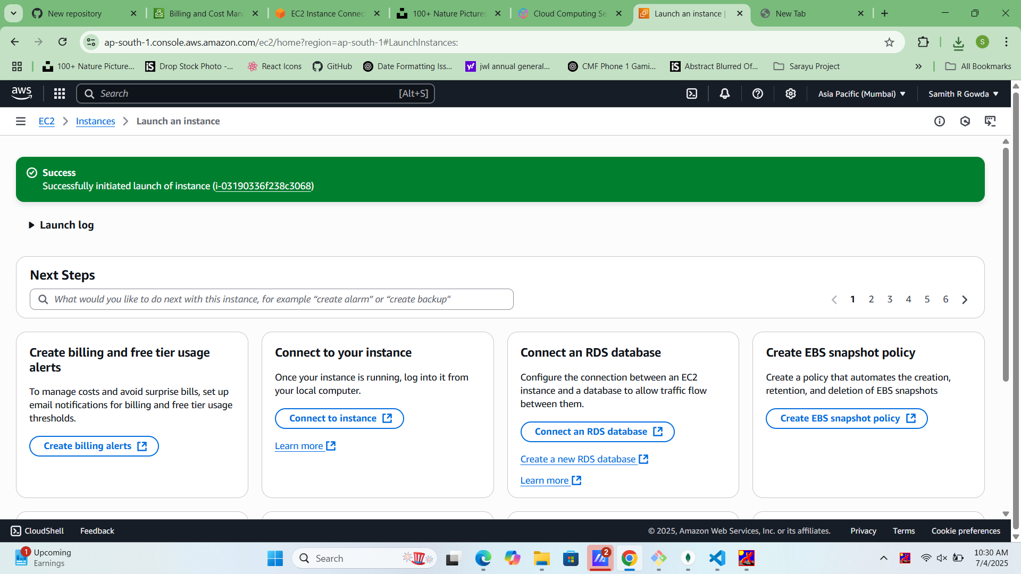

Confirmation page shows successful launch and instance ID.

## Step 12: Go to Instance Dashboard

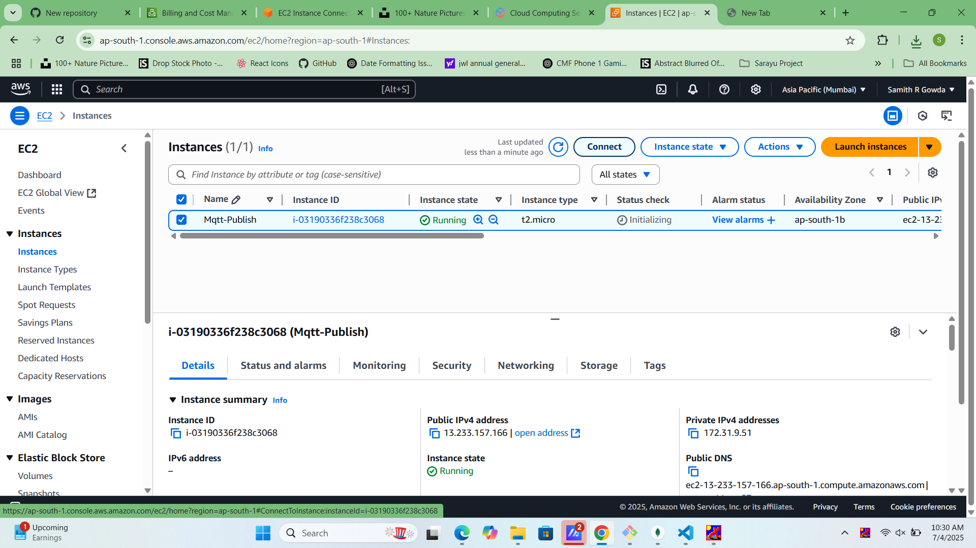

Navigate to EC2 > Instances to monitor the instance status.

## Step 13: Copy Public IP

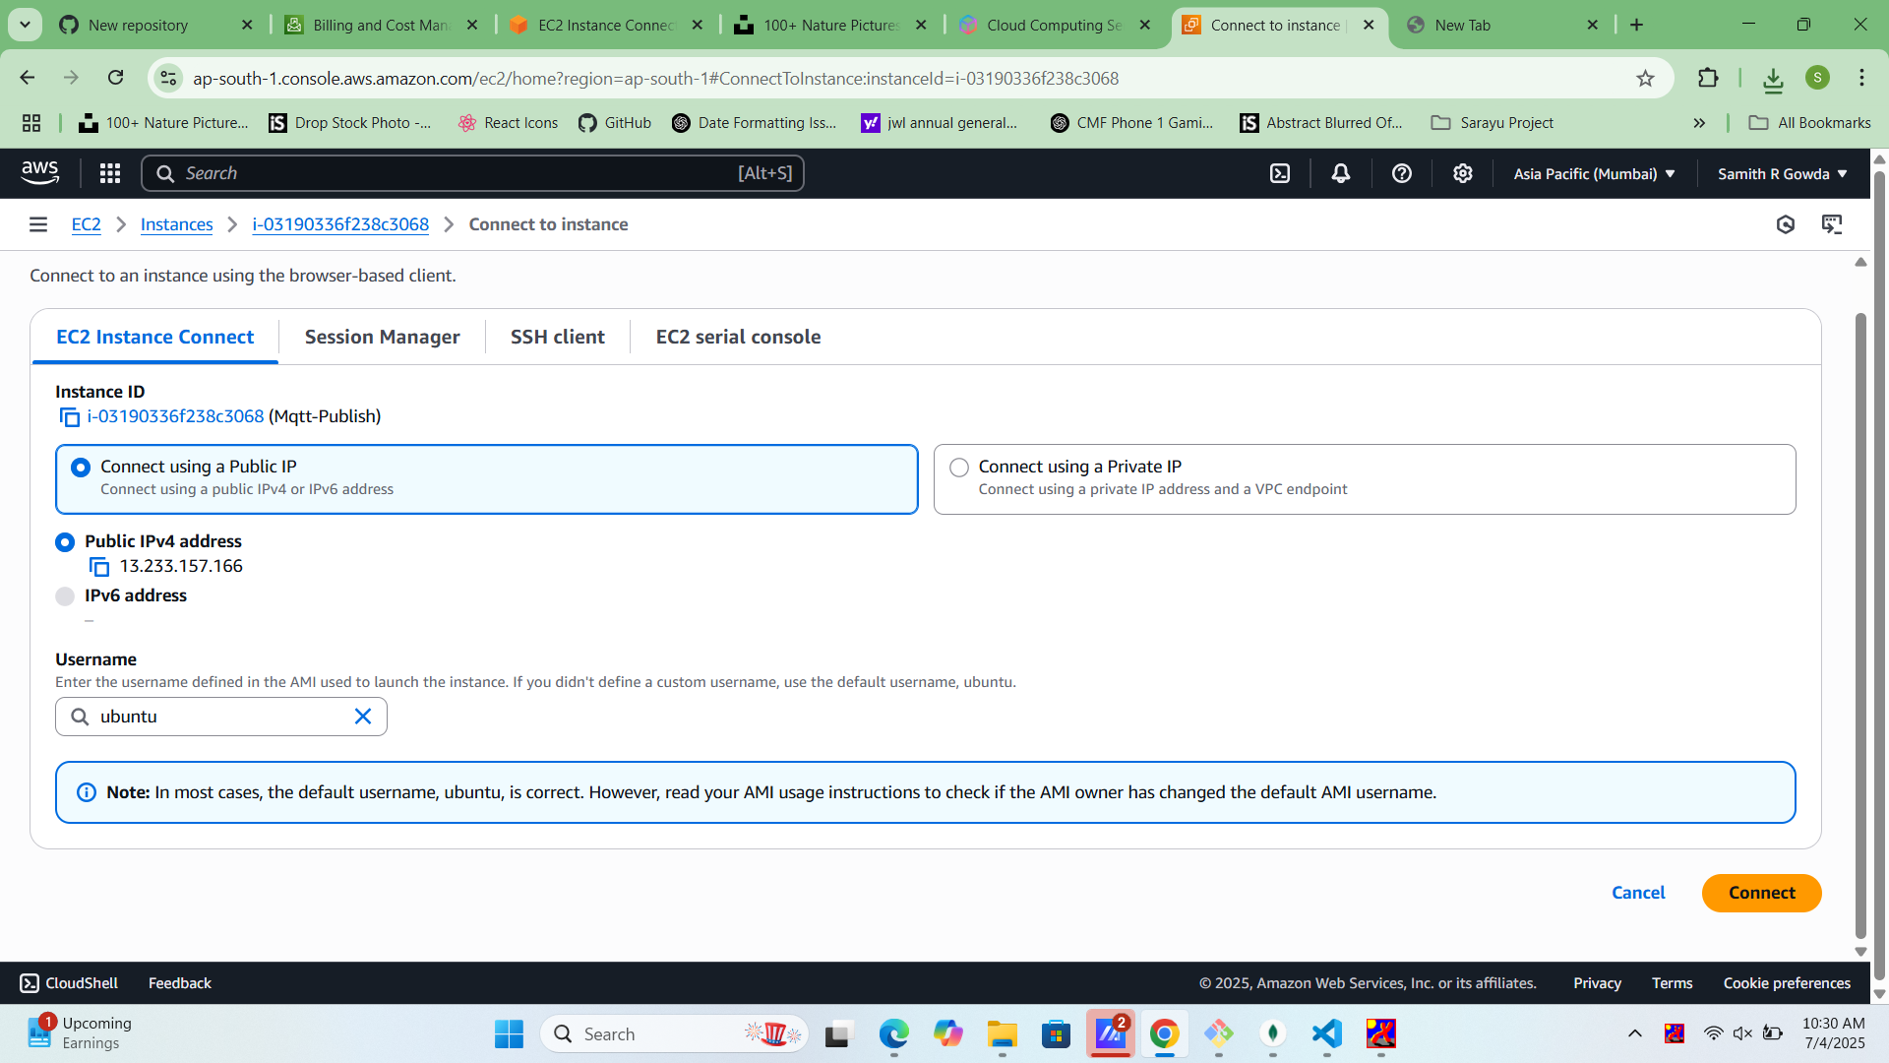

Copy the instance's public IP address to connect via SSH.

## Step 14: Connect via SSH

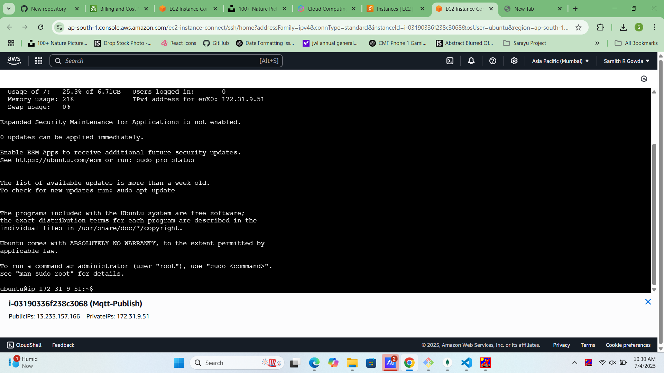

Use terminal or SSH client: `ssh -i keypair.pem ec2-user@<Public-IP>`.

## Step 15: Install Apache

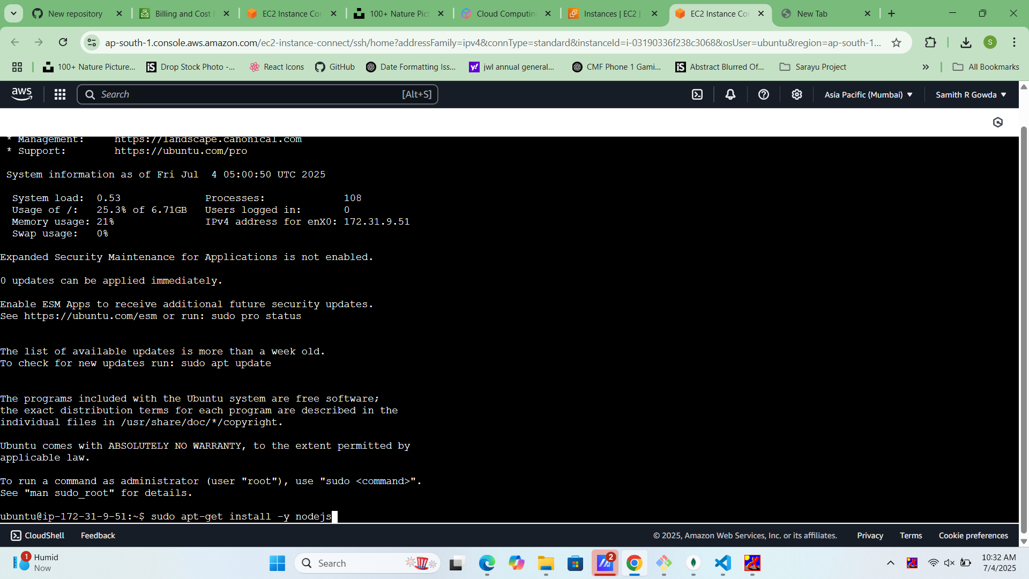

Run: `sudo yum update -y && sudo yum install httpd -y`.

## Step 16: Start Apache

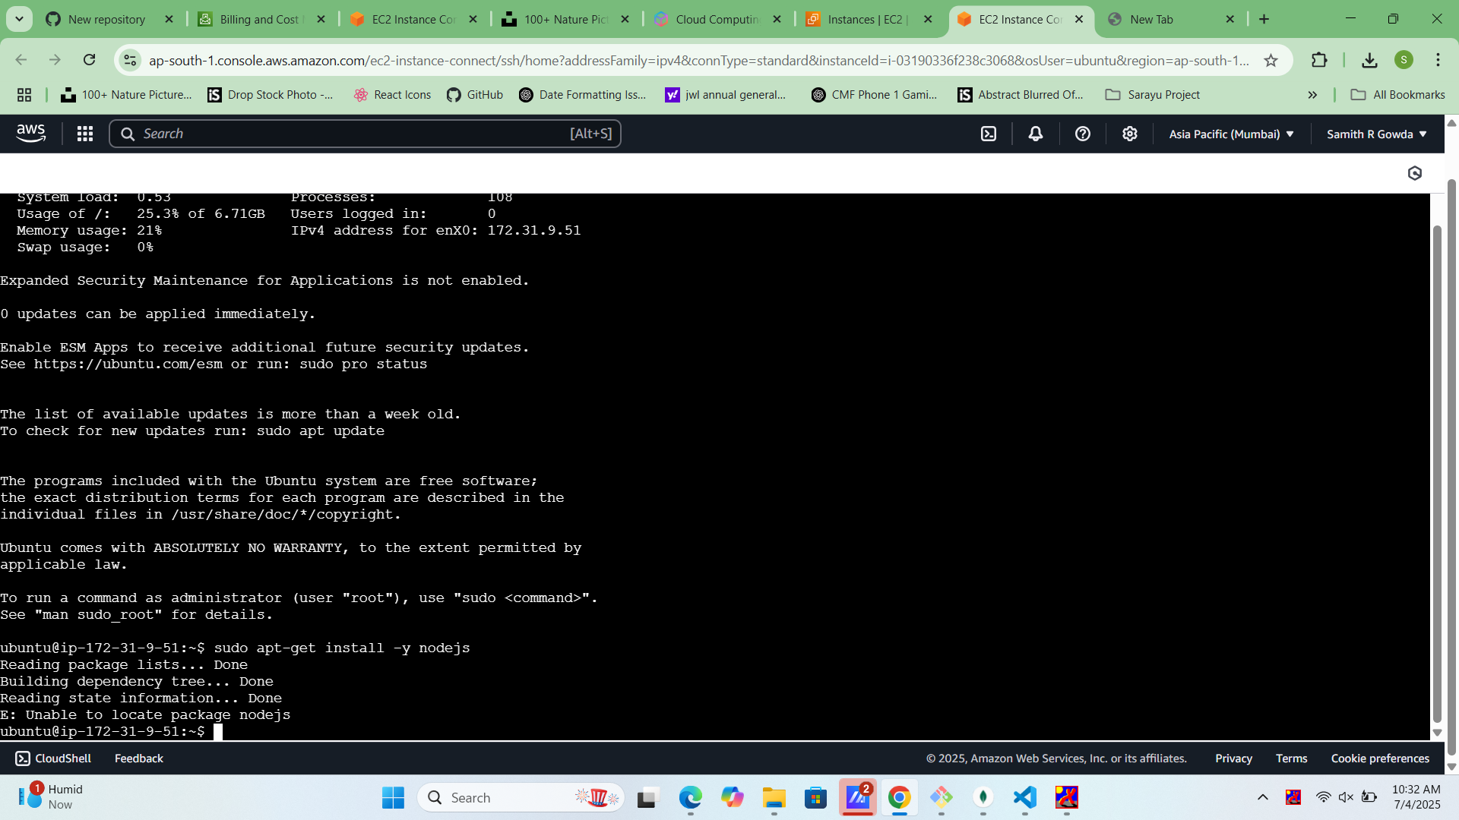

Run: `sudo systemctl start httpd && sudo systemctl enable httpd`.

## Step 17: Create HTML File

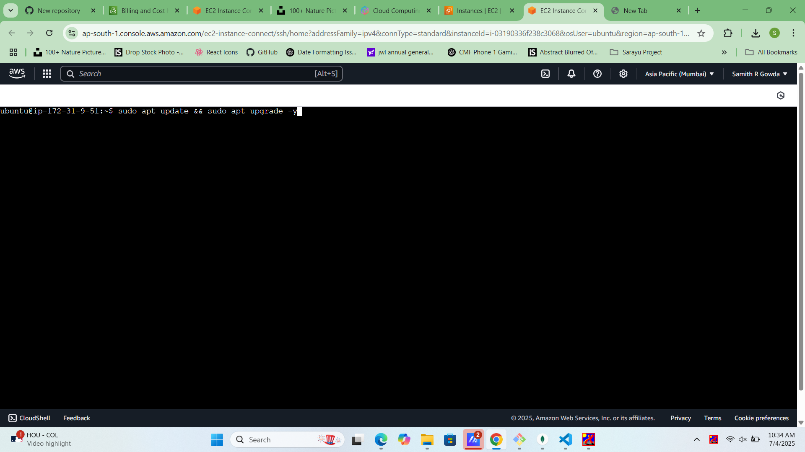

Run: `echo 'Welcome to EC2' > /var/www/html/index.html`.

## Step 18: Verify Web Page

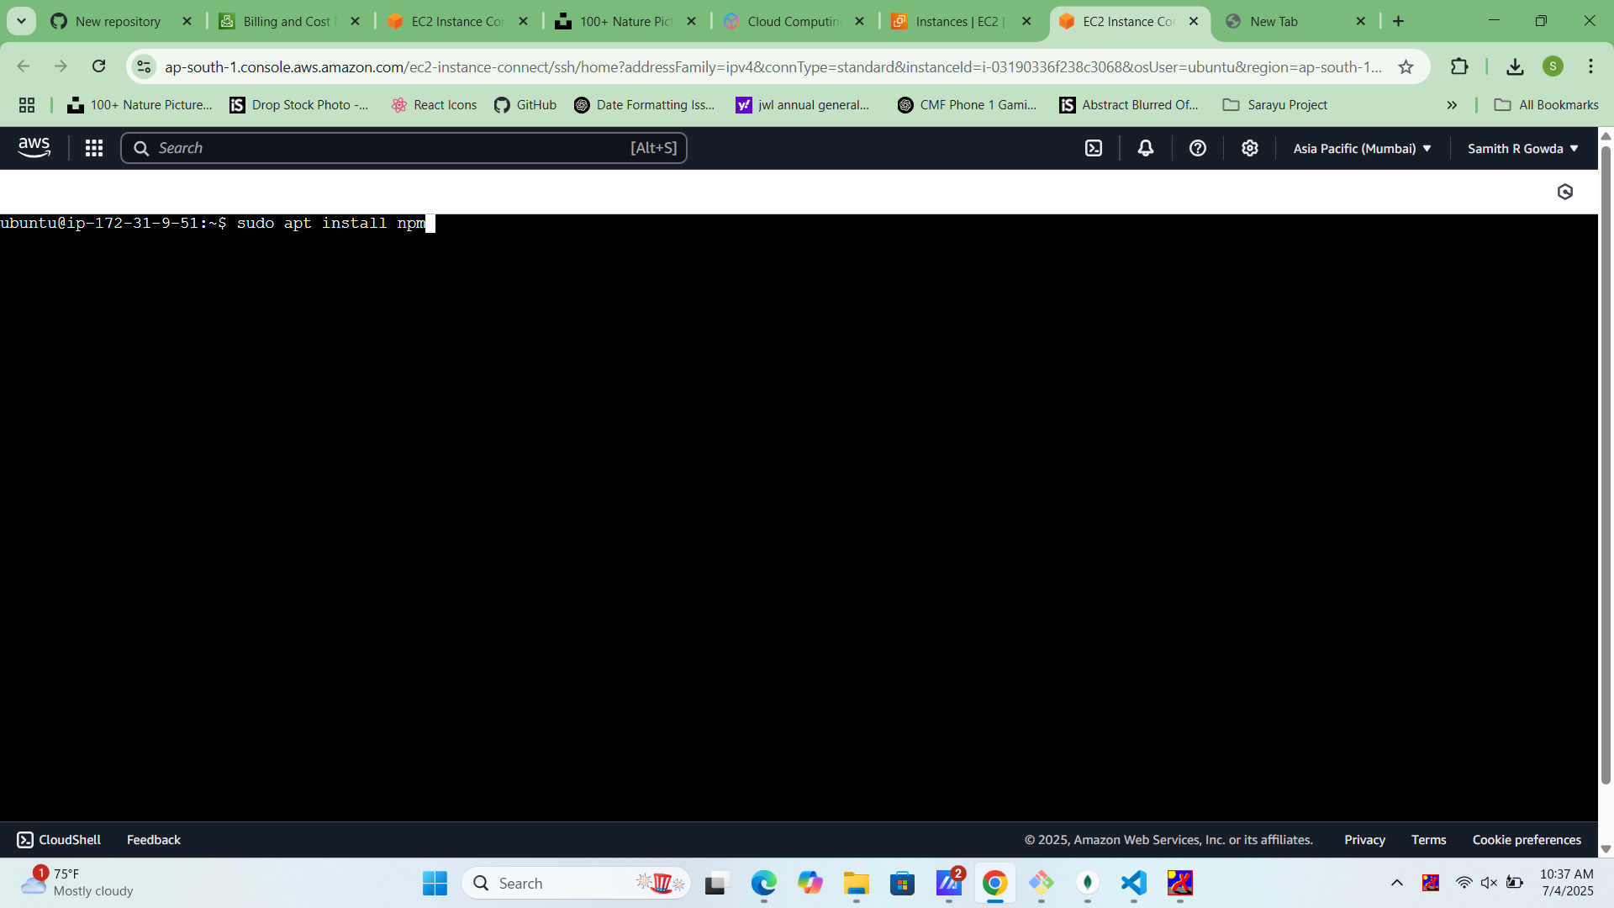

Access `http://<Public-IP>` to see the hosted webpage.

## Step 19: Configure Inbound Rules

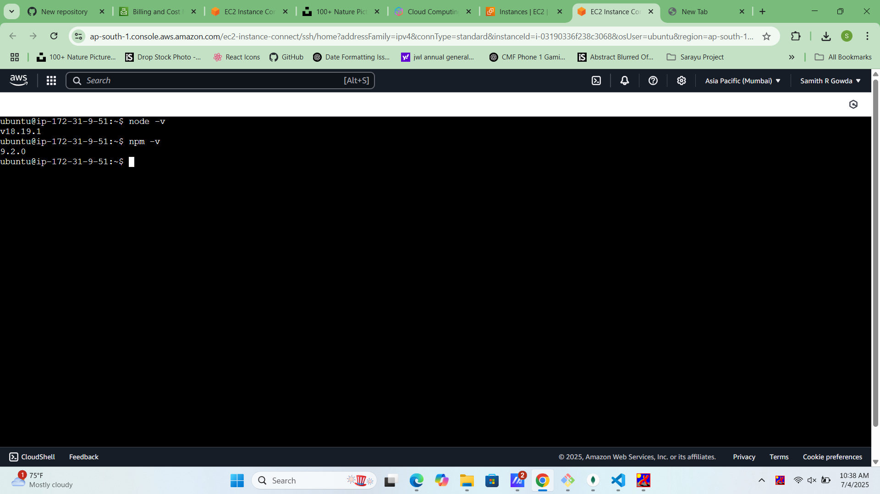

Ensure HTTP (80) is open to public in Security Group.

## Step 20: View Tags

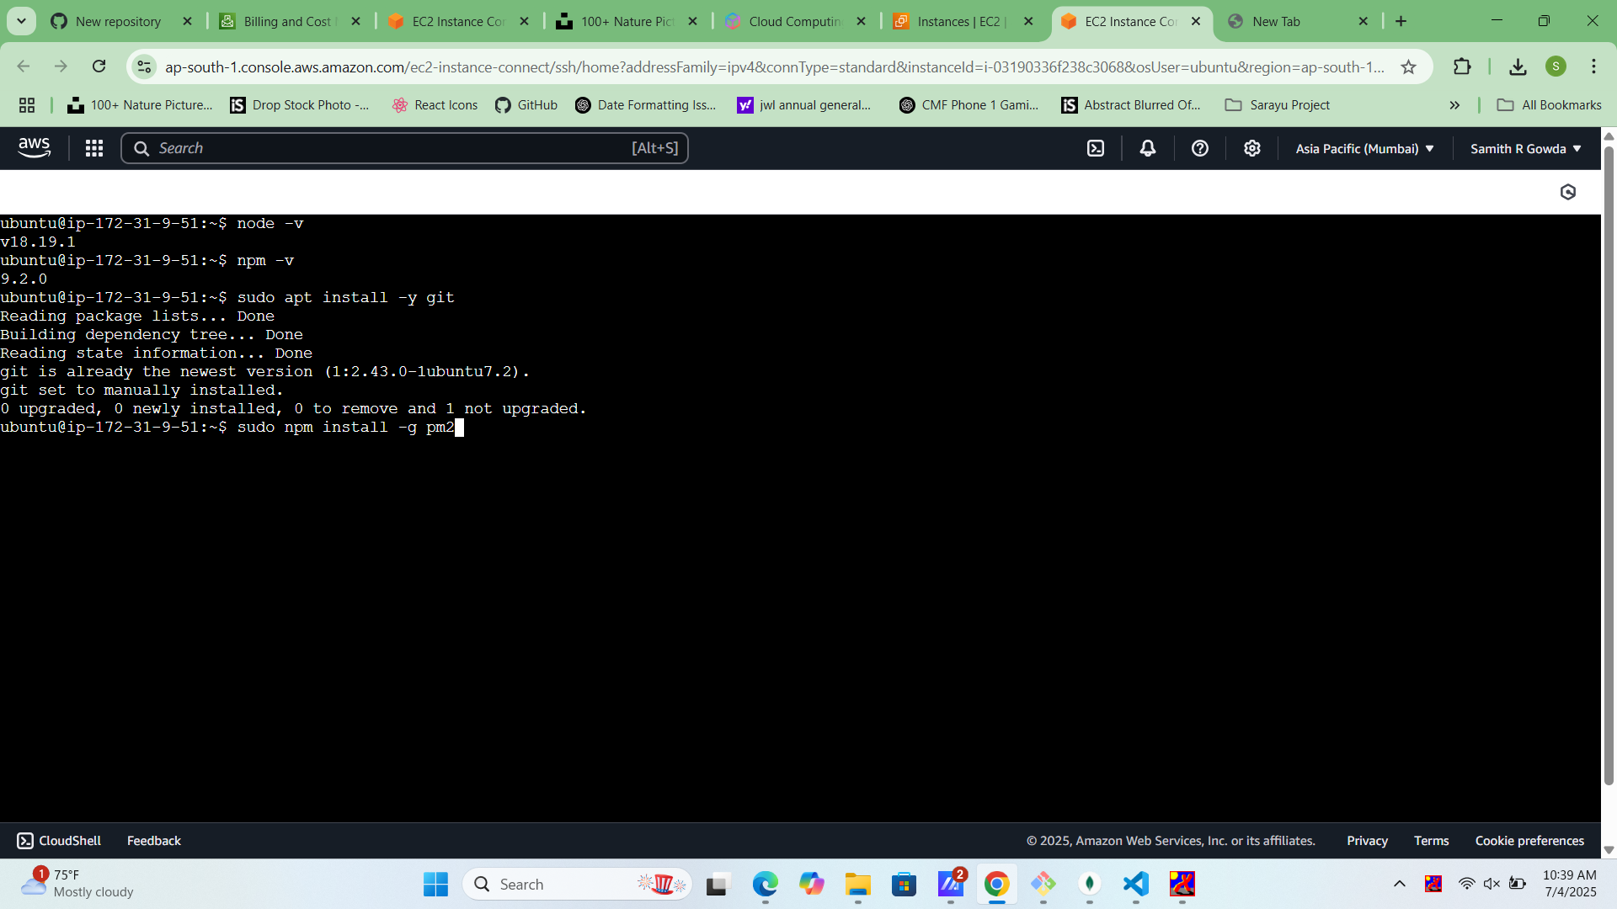

Check the tags applied to manage resources easily.

## Step 21: Monitor Instance

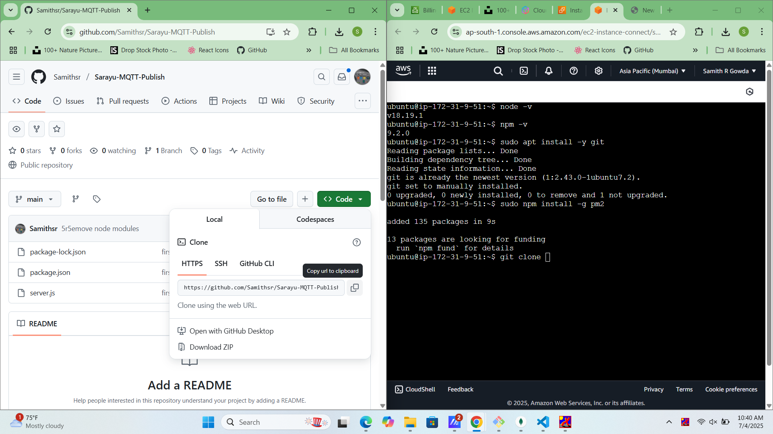

Use CloudWatch or instance metrics for monitoring.

## Step 22: Stop or Terminate

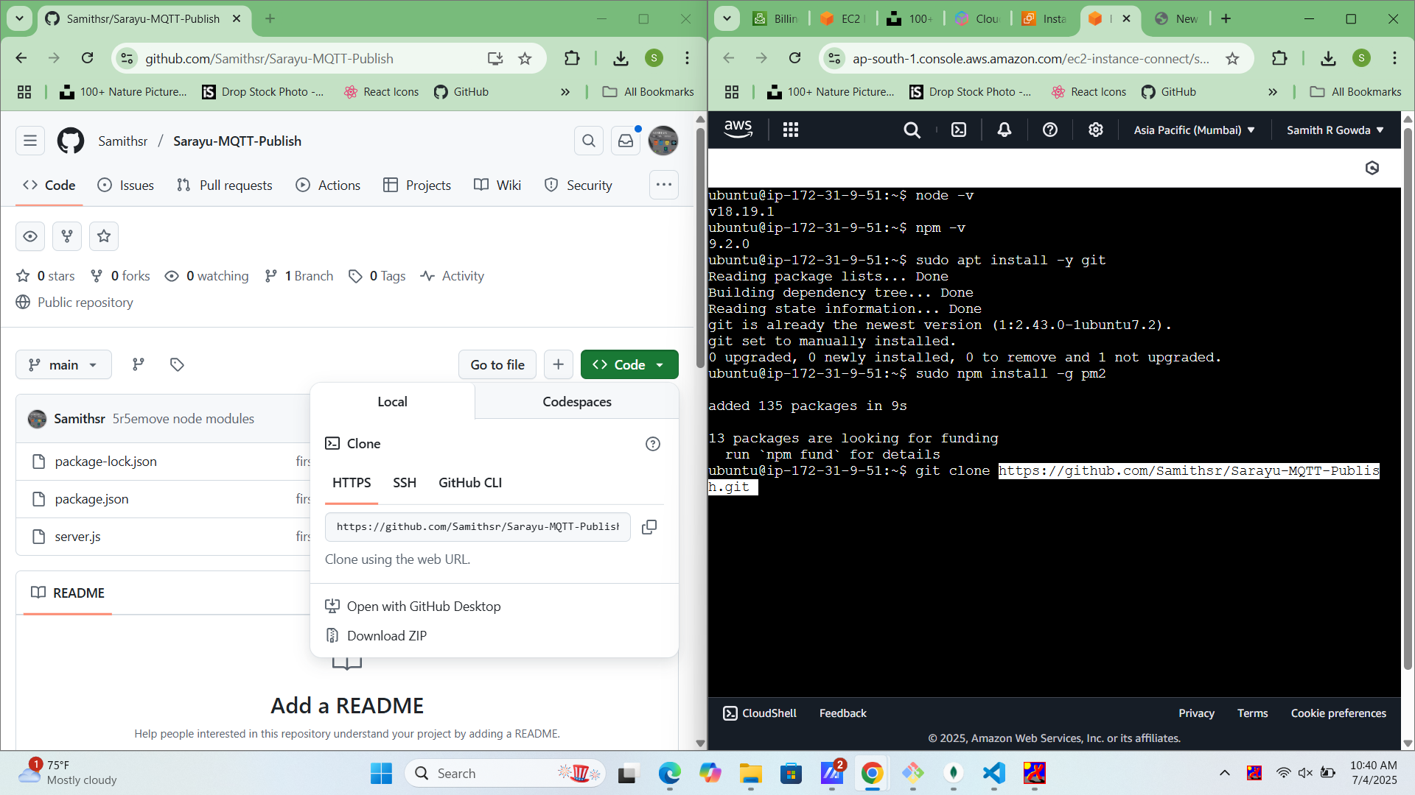

Stop or terminate the instance when no longer needed.

## Step 23: Clean Resources

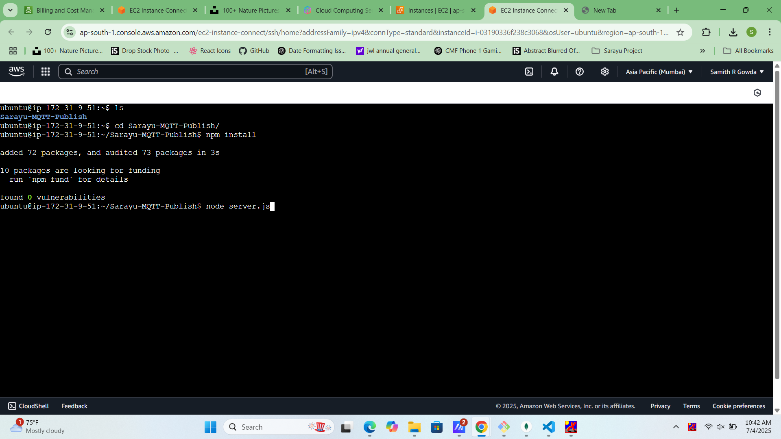

Delete unused key pairs, security groups, and volumes.

## Step 24: Billing Dashboard

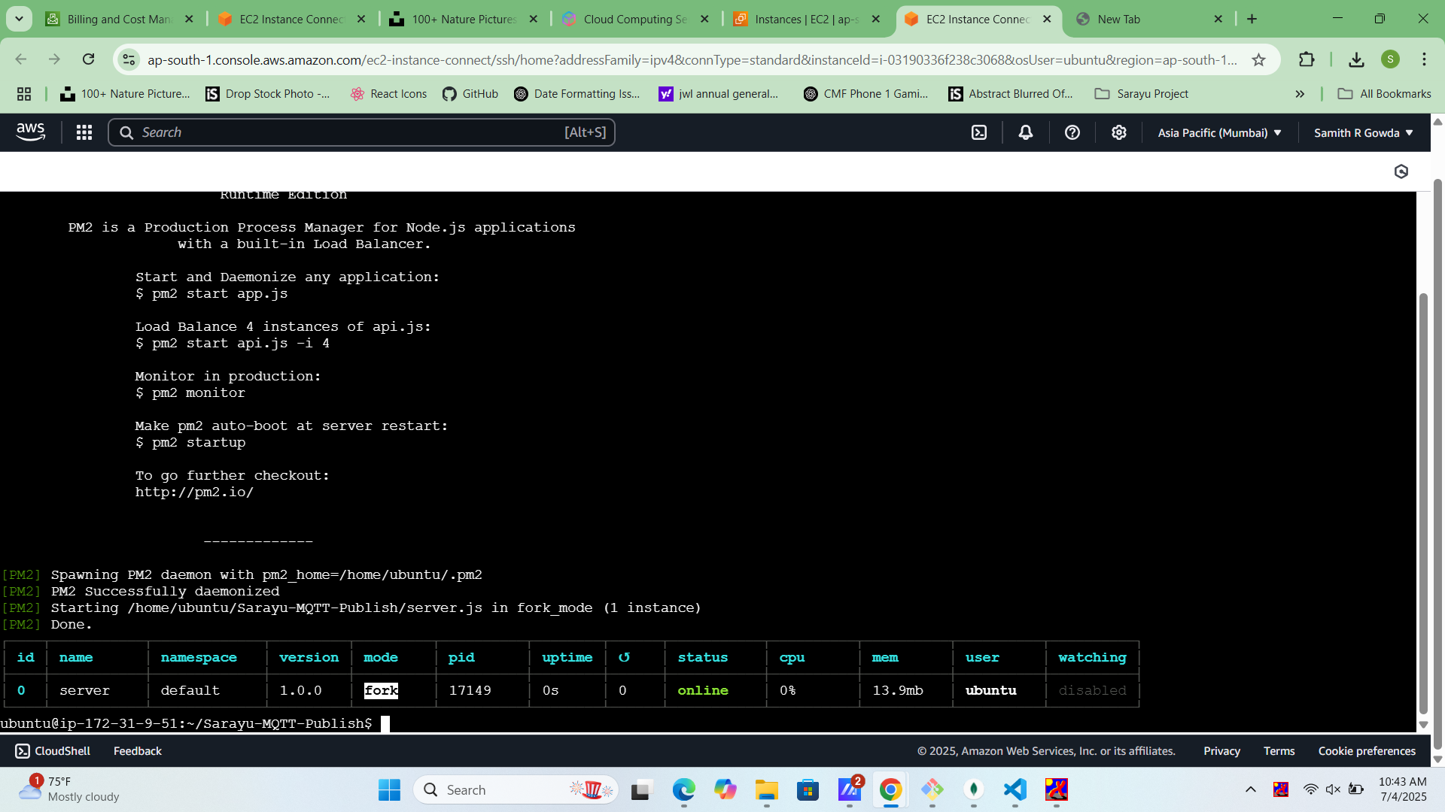

Review usage and cost in the AWS billing section.

## Step 25: Logout

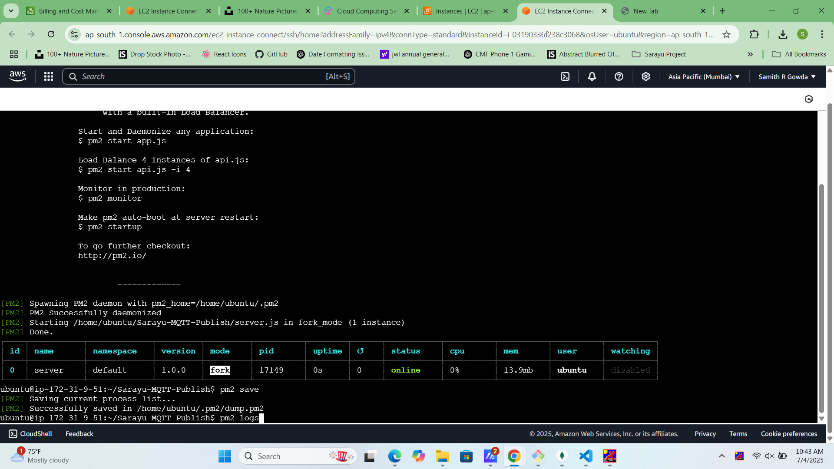

Log out from the AWS Management Console.